# **Tableau functions**

Tableau supports many functions for use in calculations. They have been organized category-wise below :

1. [Number functions:](https://help.tableau.com/current/pro/desktop/en-us/functions_functions_number.htm) Number functions allow you to perform computations on the data values in your fields. Number functions can only be used with fields that contain numerical values.

Some of the available number functions are:

**ABS**

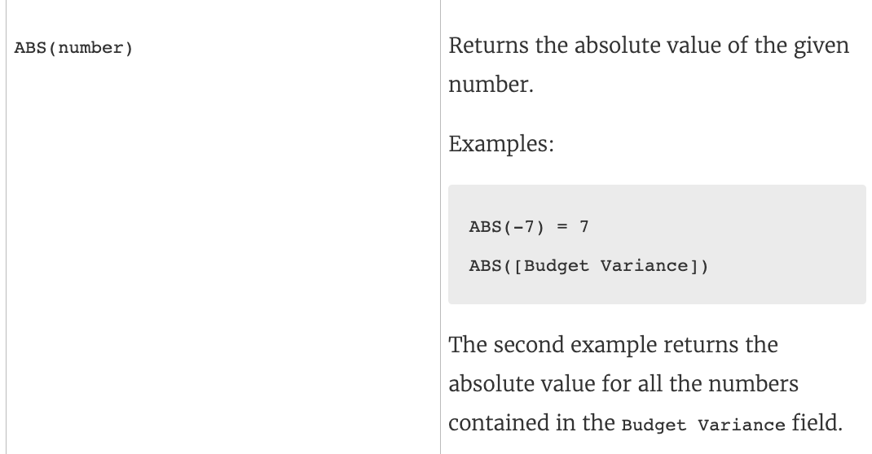

**Ceiling**

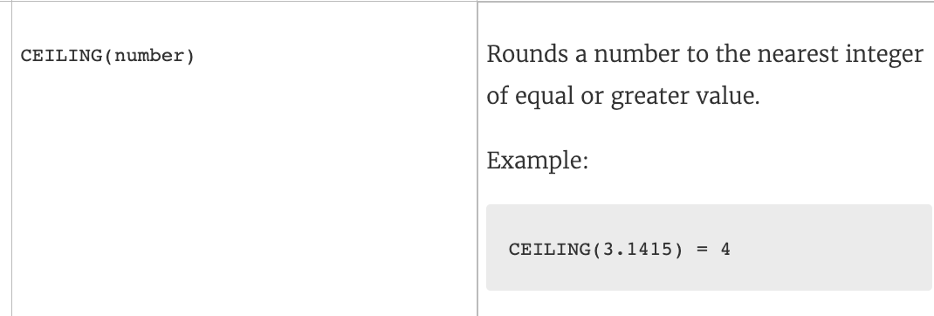

**DIV**

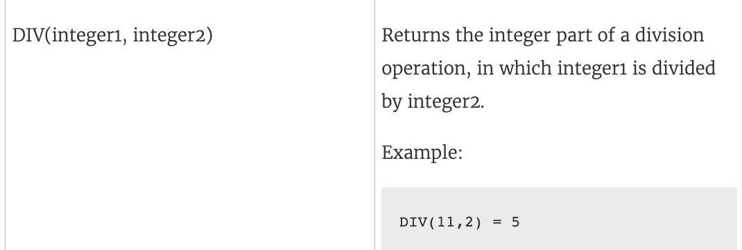

1. [String functions:](https://help.tableau.com/current/pro/desktop/en-us/functions_functions_string.htm) String functions allow you to manipulate string data (i.e. data made of text).

Some of the available string functions are:

**Contains**

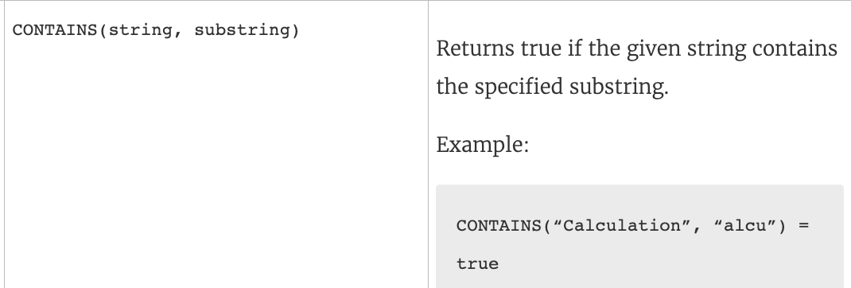

**ENDSWITH**

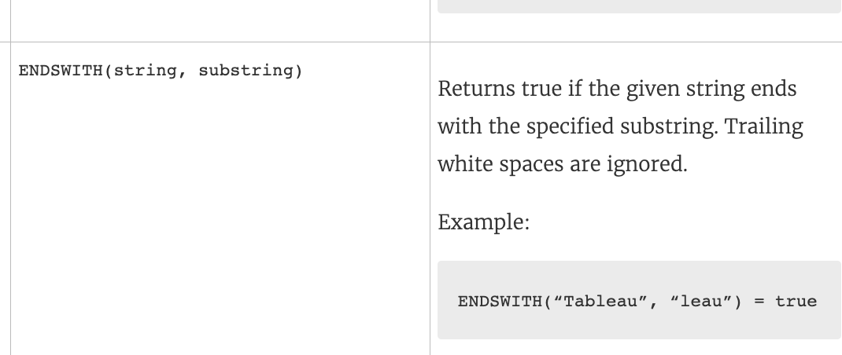

**LOWER**

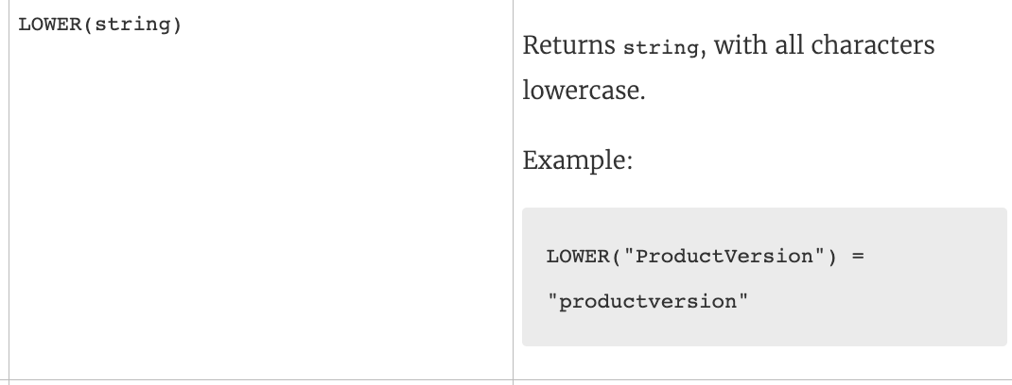

1. [Date functions :](https://help.tableau.com/current/pro/desktop/en-us/functions_functions_date.htm) It allows you to manipulate dates in your data source.

Some of the date functions are:

**DATENAME**

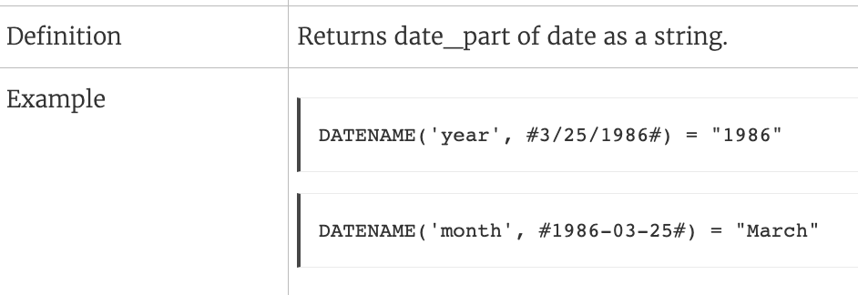

**DATEPART**

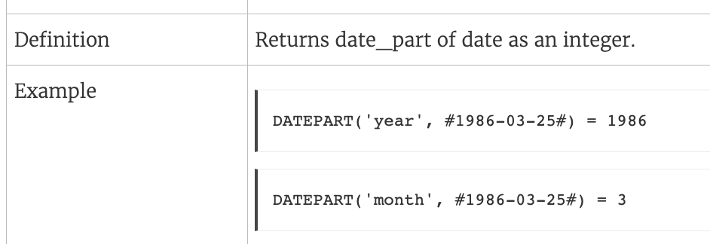

**ISDATE**

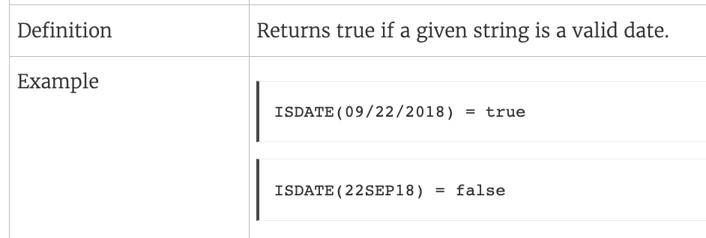

1. [Logical functions](https://help.tableau.com/current/pro/desktop/en-us/functions_functions_logical.htm): Logical calculations allow you to determine if a certain condition is true or false (boolean logic).

Some logical functions are:

**IFNULL**

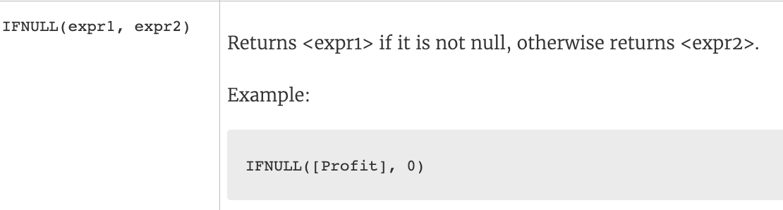

**NOT**

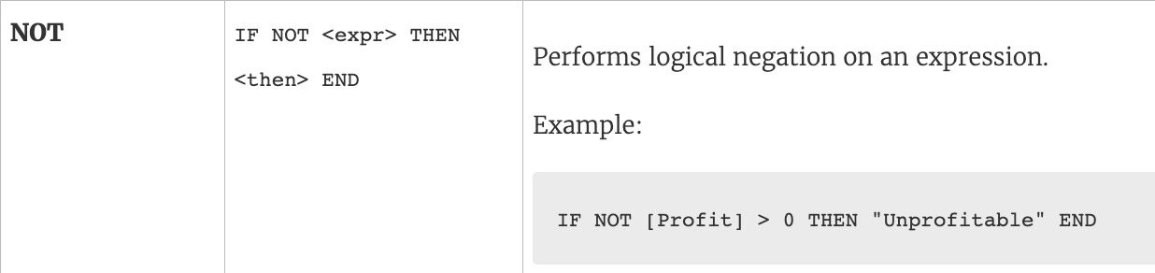

**MIN**

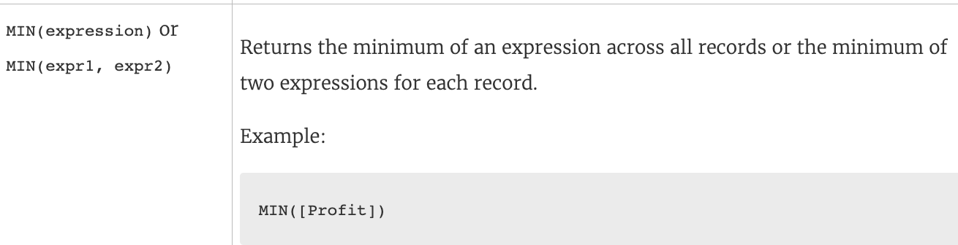

1. [Aggregate functions:](https://help.tableau.com/current/pro/desktop/en-us/calculations_calculatedfields_aggregate_create.htm) Aggregate functions allow you to summarize or change the granularity of your data.

Some of the available aggregation functions are:

**AVG**

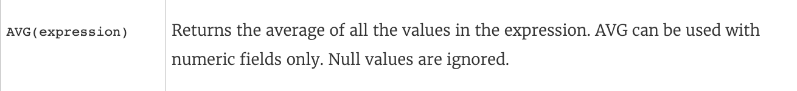

**COUNT**



**PERCENTILE**

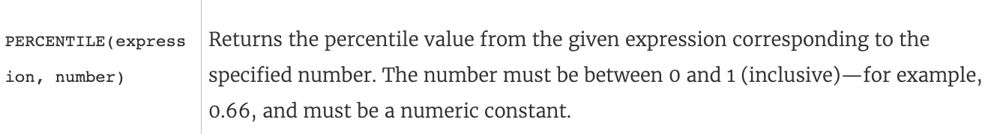

1. [Table calculations functions:](https://help.tableau.com/current/pro/desktop/en-us/functions_functions_tablecalculation.htm) Table calculation functions allow you to perform computations on values in a table.

Some of the available aggregation functions are:

**Index**

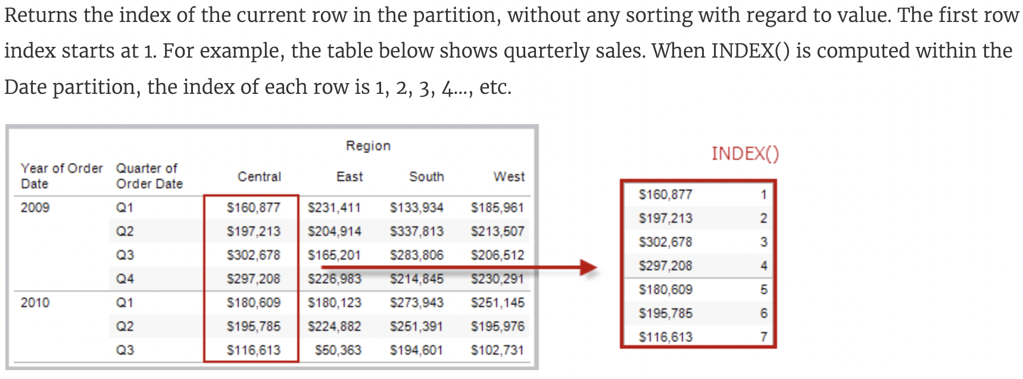

**Running Sum**

